Neoprene Wrist/Thumb Gauntlet Order Form

Client:
DOB
Address:
NDIS No.:
NDIS Funding is : Self-Managed Plan Managed NDIA Managed

Client Name:
Parent/Carer:
Mobile:
Email:

Referring Therapist:
Mobile:
Email:

Client Diagnosis:
Movement disorder type: Spastic Dyskinetic/Dystonic Mixed
GMFCS Level Equivalent: I / II / III / IV / V
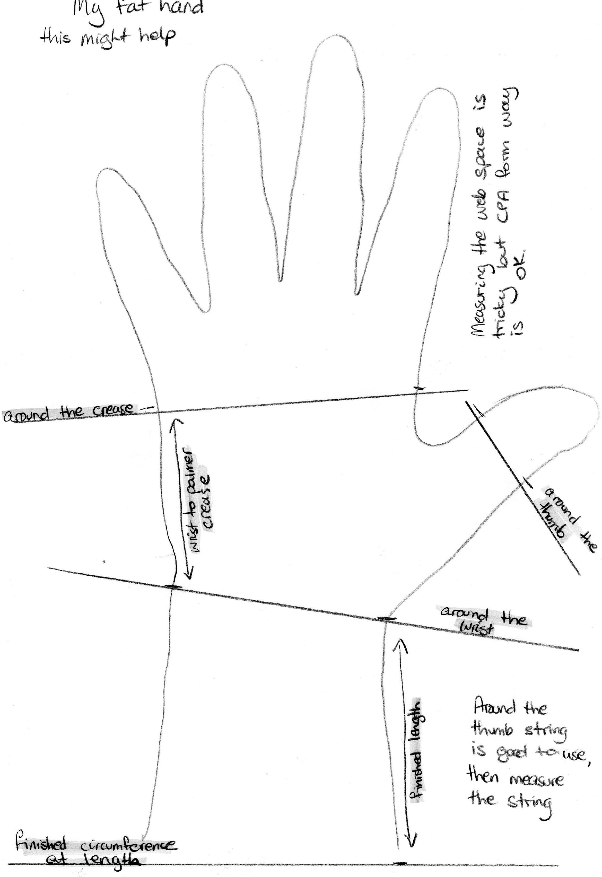
Please provide tracing and measurements as seen in example on the left. For best fit we require true outline and landmark markings, ensure the pen/pencil is placed perpendicular to the paper, do not allow pen/pencil to angle inwards underneath the hand and wrist. Measurements should be as exact as possible, allowances will be made at pattern making stage. Please also send a photograph of the client’s palm.
1
MCP
DIP
If a thermoplastic insert is required, the insert should be moulded around the base material. A pocket will then be made to accommodate the insert to ensure good fit.
5
3
7
6
W
2
Wrist Crease
All measurements should be made with wrist in a neutral position. If you are unable to position your client’s wrist and thumb into a neutral position, please contact Rehab Therapies to discuss further.
*
8
+++
4
Measurements (in cms)
 | Left | Right
1. Palm circumference
2.Wrist Circumference
3. Thumb Circumference*
4.Forearm circumference
5. Web space measure 1 measure in a functional position +++
6. Web Space measure 2 measure in functional position +++
7. Palm length
8. Desired forearm length

Thermoplastic insert pocket required? Yes/No

Thumb Spica Required? Yes/No

Pull of closure:
Pull from Radial Side
Pull from Ulnar side

Type of Closure:
Velcro
Zipper

Position of closure:
Centre of dorsum/back of hand
Close to thumb
Close to little finger

Other information/Requests:

Please send completed forms to: enquiries@rehabtherapies.com.au
Manufacturing begins only after quote is accepted by and funding confirmed.

Hand and Wrist Tracing and Markings

