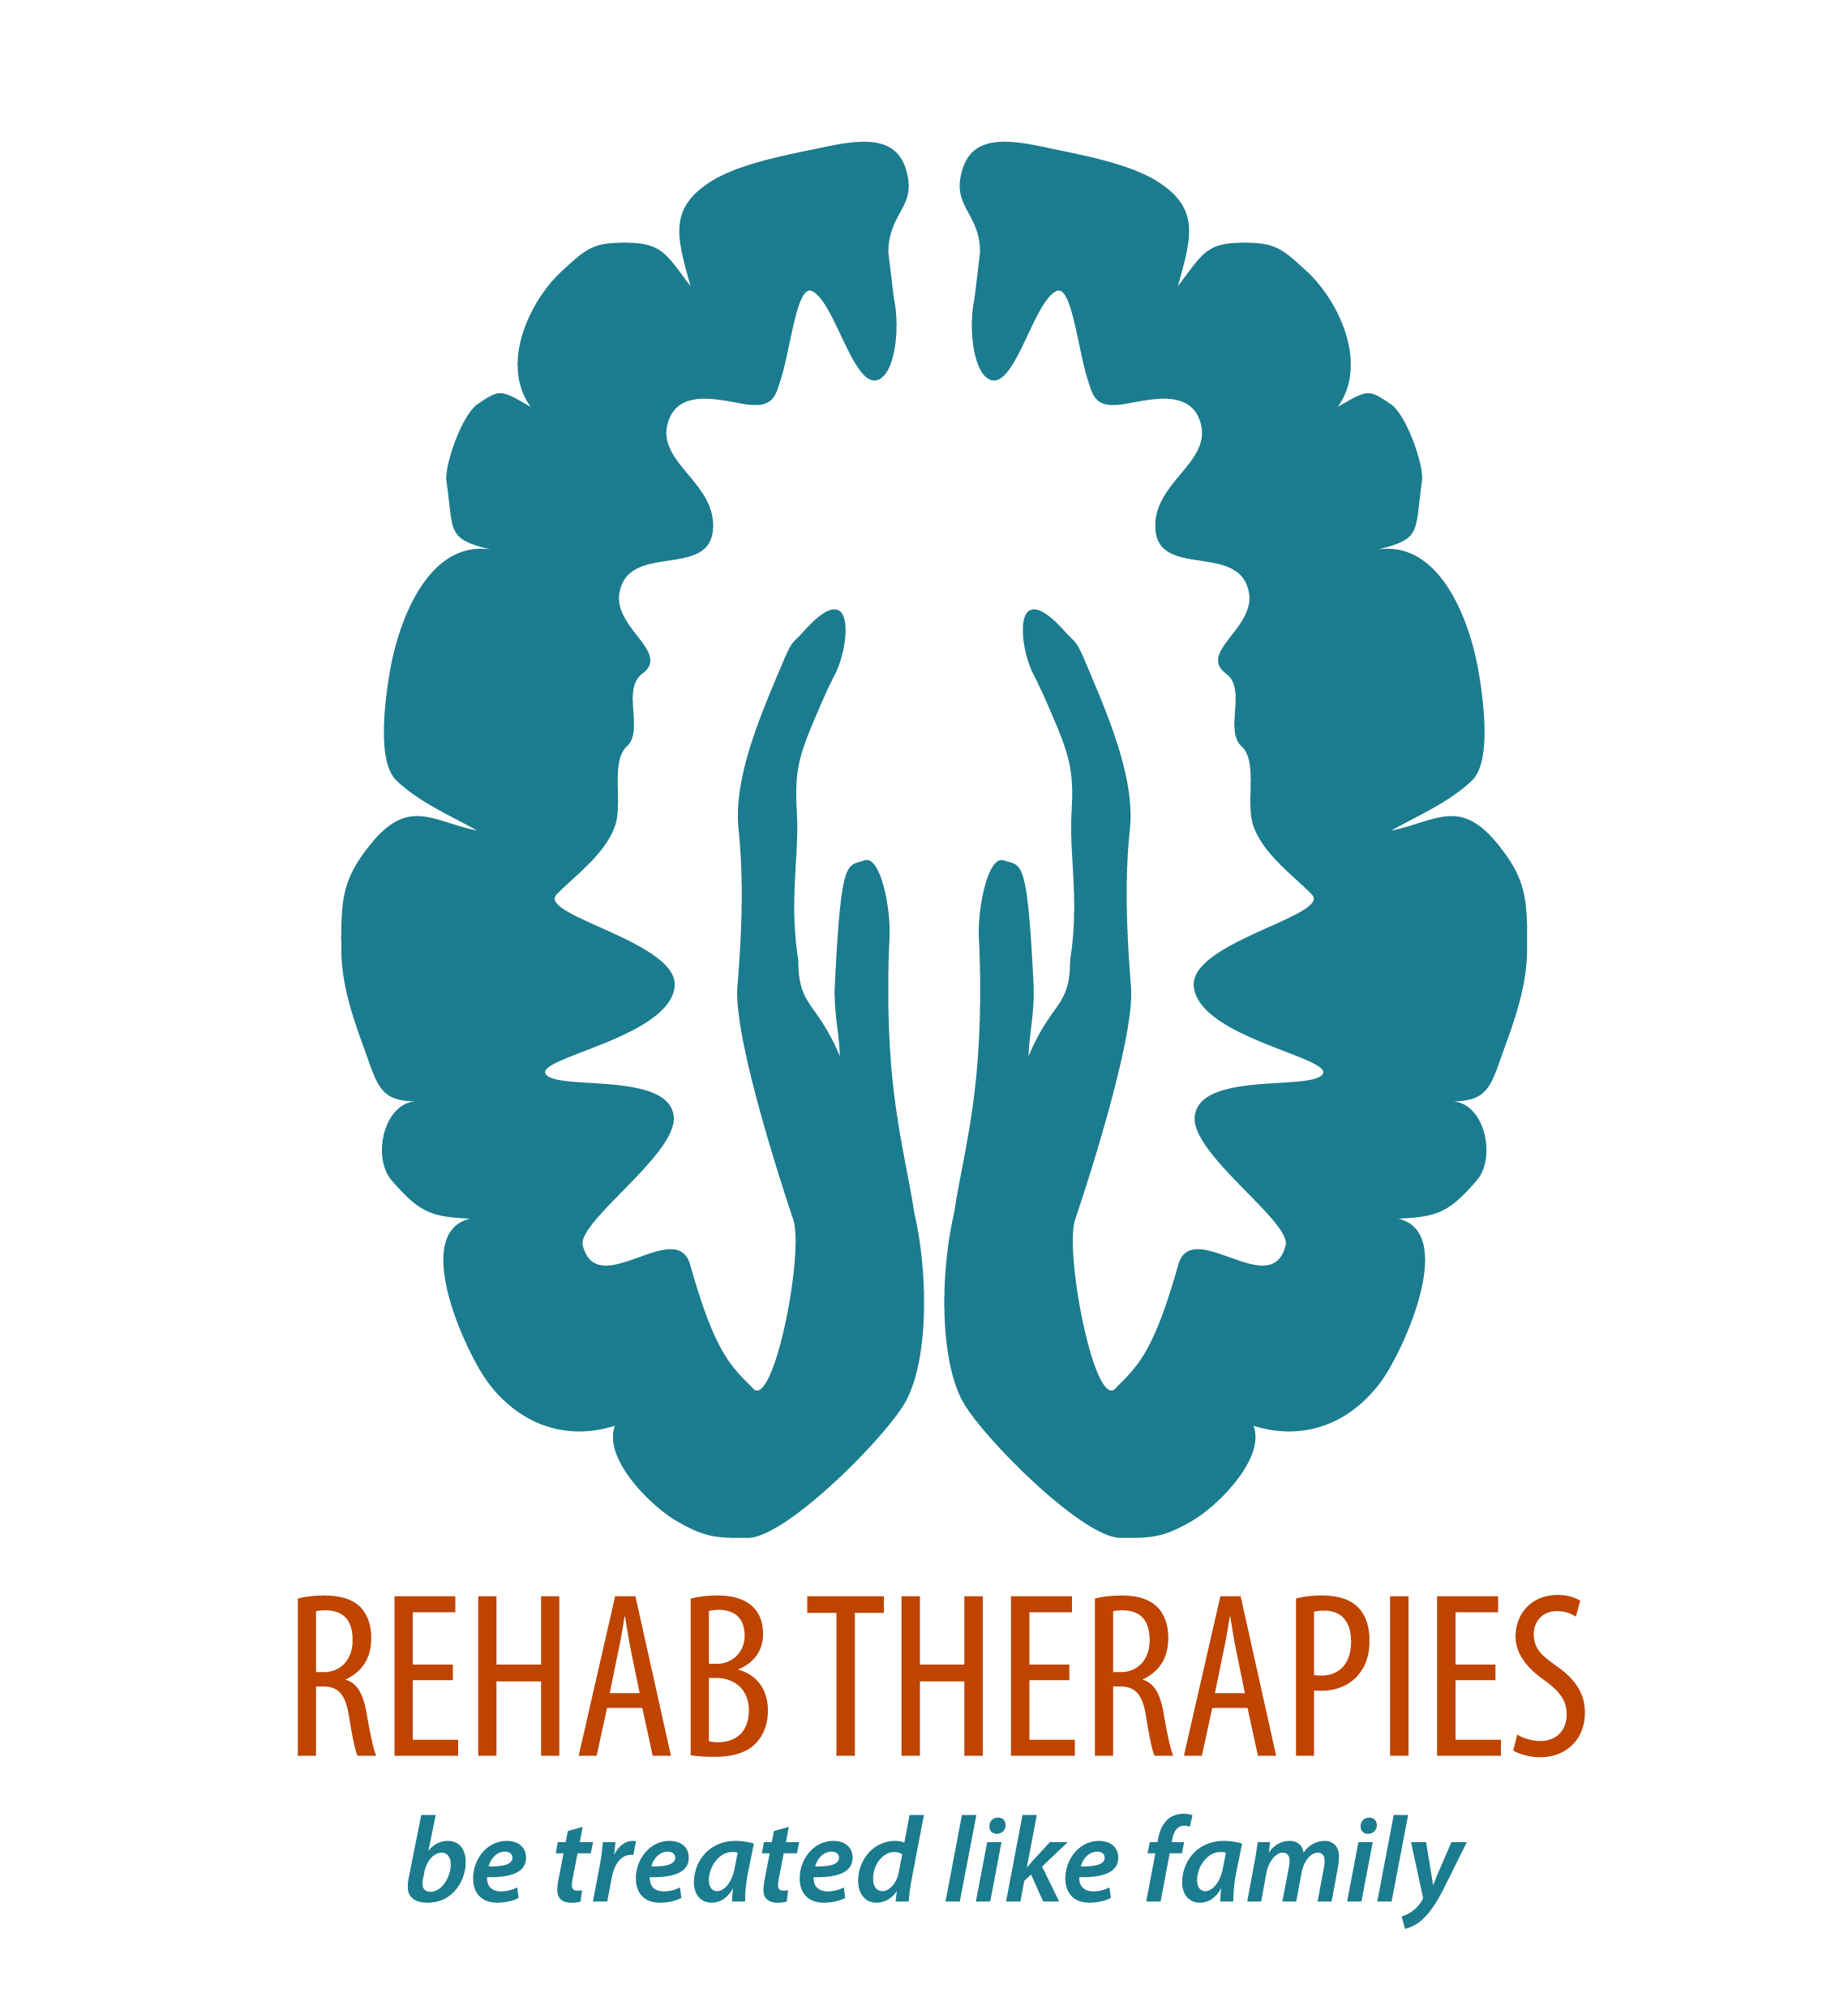
COVID-19 Safety Plan
COVID-19 is highly contagious and the main concern is the load on the health system and the effect it has on the more at-risk population: The elderly, immunosuppressed, those with Chronic respiratory illness and those with more fragile health. Few accounts of children have died form COVID-19. We need to do all that we can to prevent spreading the virus and affecting those more vulnerable around us and in society.
Until an effective vaccine is available and widely used, it is vital for us to continue to be vigilant to protect our staff, clients and our families. Rehab Therapies (RT) will regularly update our safety plan to ensure it remains effective.
Wellbeing of Staff and Clients:
Symptoms of COVID-19 include fever (≥37.5), cough, sore throat, shortness of breath (difficulty breathing), loss of smell and loss of taste.
Other reported symptoms of COVID-19 include fatigue, runny nose, muscle pain, joint pain, headache, diarrhoea, nausea/vomiting and loss of appetite. In more severe cases, infection can cause pneumonia with severe acute respiratory distress.
NSW Health recommends that anyone with respiratory symptoms, loss of sense of smell or taste, or unexplained fever should be tested for COVID-19.
This is especially important for:
- anyone who lives or works in a high-risk setting, including healthcare facilities, aged care and other residential facilities, schools, prisons, and other closed settings
- Aboriginal and Torres Strait Islander people
- people who are close contacts of a confirmed case
- people who have returned from Victoria or exempted overseas travellers in the last 14 days
- anyone admitted to hospital.

RT staff should make sure that the laboratory request form notes that you are a health care worker so that your test can be prioritised.
Routine tests for acute pneumonia/pneumonitis should also be performed where indicated according to local protocols.
Actions By RT Staff | Actions by Clients
If unwell and require COVID-19 test, please inform Jenny or Glenda and cancel all appointments for next 48hrs until COVID-19 test results are received. | If client or anyone in their household is unwell, and presenting with flu like symptoms please contact us on 1300 832 839 or enquries@rehabtherapies.com.au to cancel your upcoming appointments.
Self- Isolate until results are received | Get COVID-19 test and self-isolate until results received.
If you receive a negative test but remain unwell with fever, sore throat and other flu like symptoms, please cancel all appointments for next week and only resume seeing clients after symptoms subside | Resume therapy only after negative test results and flu-like symptoms subside
If you discover that your client or anyone in the family is unwell with respiratory symptoms, please do not enter the premises or leave as soon as you can politely do so. | Please note that should our staff member discover that a client or someone in the household is unwell, they have been asked to not enter or discontinue therapy and leave the premises. The session will still be charged.  Our cancellation policy requires that you provide 48-hour notice or full hour therapy charge will apply.
If you need to have 2 weeks leave due to COVID-19 please discuss leave arrangements with Jenny
Test temperature if seeing client in clinic
COVID-19 Testing clinic locations can be found:
https://www.health.nsw.gov.au/Infectious/covid-19/Pages/clinics.aspx

Physical Distancing
Actions by RT Staff | Actions By Clients
Keep physical contact limited to clients only. Minimise physical contacts as you are able. | Only clients should have physical contact with RT staff. No physical contact between RT staff and family members or carers.
Remind families that only 1 other family member should be in the room during therapy | In addition to the client, only 1 other family member or carer to be in the room during therapy
Encourage families to allow therapy to occur in a larger space with good ventilation. Perhaps keep a door or window open if weather permits. Consider having therapy outdoors if able. | Please provide a large room with good ventilation for therapy. If the weather permits, please consider using and undercover outdoor space to prevent being indoors
Use telephone or video conferencing where for discussions or meetings to prepare for planning meetings | Use telephone or video conferencing where for discussions or meetings to prepare for planning meetings
Please avoid any joint therapy sessions with other therapists | Please avoid any joint therapy sessions e.g. OT and Physio together
Aquatic Physiotherapy  Sessions are limited to a total of 3 clients  Clients are each allocated their own change rooms | Aquatic Physiotherapy  Only use allocated change room  Keep 1.5m distance from other clients as able
Hygiene, Cleaning and Personal Protective Equipment (PPE)
Actions by RT Staff | Actions By Clients
Wear masks and protective eye gear (or your glasses) provided before entering premises for therapy. Please discard masks at end of the day and use a new mask at the beginning of the day.
Remove shoes once you enter premises unless advised otherwise. | Advise staff if they should keep shoes on.
Double check if large surfaces have been disinfected. Use provided disinfectant wipes provided if needed. | Clean and disinfect surfaces prior to therapy session. In particular tables and chairs to be used in session
Wash hands at the beginning and end of session. | Show staff to appropriate room to wash hands at the beginning and end of session
Put on gloves provided after you have washed your hands and remove them at the end of the session. Gloves should be discarded in client’s home, single use only. | Please show staff where they can dispose of gloves.
Try to use client’s own toys and equipment when possible.
Disinfect all toys and equipment used during the session prior to and after use.
Use hand sanitiser provided in between sessions and when you are unable to wash your hands
Wash your outfits at the end of each day.
Aquatic Physiotherapy  Clean and disinfect beds, chairs, handrails, water wheelchair, door handles, and frequently touched areas with spray disinfectant cleaner provided. Spray and leave for 30s-1min before wiping as instructed by Jenny. | Aquatic Physiotherapy  Please wait for change areas to be cleaned and disinfected before entering.
 | Clients are to use their own sling for hoists
 | Clients are to purchase and use their own floatation aids
Record Keeping
Actions By RT Staff | Actions By Clients
Keep Cliniko appointments up to date | Please update your mobile number and email address with Glenda on 1300 832 839
Record who attended session in your notes in Cliniko
Please download and use COVIDSafe App | Please download and use COVIDSafe App
Cooperate with NSW Health if contacted in relation to a positive case of COVID-19 at your workplace and notify SafeWork NSW on 13 10 50. | Cooperate with NSW Health if contacted in relation to a positive case of COVID-19
Changes to our Service
- Therapy in schools have resumed
- Aquatic Physiotherapy resumed at Lakeview Hospital and soon to be resumed at The Hills School
- Staff will not attended appointments with families at hospitals or medical centres until further notice
- No Group therapy sessions until further notice
We know that usual check-ups with many of your medical teams have been postponed or conducted Via teleconference only. Our team is conscious of this change and will therefore assist with any liaison and feedback to medical team to ensure you continue to receive the treatment you need. Please do not hesitate to ask for our guidance should you have any health-related concerns during this time.
Let’s keep working together to protect and help those who really need it. We are endeavouring to keep you safe during this COVID-19 Pandemic and provide you with the therapy you need and are used to.
Kind Regards,
Jenny Wu
Physiotherapist and Owner
